Yinghui Qiang 19692

MATH201 - Calculus-I

Homework Assignment #3

Due day: 6/23/2023

1. If a rock is thrown upward on the planet Mars with a velocity of 10 m/s, its height in meters *t* seconds later is given by

(a) Find the average velocity over the given time intervals:

(i) [1, 2] (ii) [1, 1.5] (iii) [1, 1.1]

(iv) [1, 1.01] (v) [1, 1.001]

ANS:

Average velocity = =

1. Distance (1) = 10\*1-1.86 \* = 8.14

Distance (2) = 10\*2-1.86\* = 12.56

V = (12.56- 8.14) / (2-1) = 4.42

Therefore, the average velocity is 4.42 meters per second.

1. Distance (1) = 10\*1-1.86 \* = 8.14

Distance (1.5) = 10\*1.5-1.86\* = 10.815

V = (10.815-8.14) / (1.5-1) = 5.35

Therefore, the average velocity is 5.35 meters per second.

1. Distance (1) = 10\*1-1.86 \* = 8.14

Distance (1.1) = 10\*1.1-1.86\* = 8.7494

V = (8.8494 – 8.14) / (1.1-1) = 6.094

Therefore, the average velocity is approximately 6.1 meters per second.

1. Distance (1) = 10\*1-1.86 \* = 8.14

Distance (1.01) = 10\*1.01-1.86\*= 8.2026

V = (8.2026-8.14) / (1.01-1) = 6.26

Therefore, the average velocity is 6.26 meters per second.

1. Distance (1) = 10\*1-1.86 \* = 8.14

Distance (1.001) = 10\*1.001-1.86\* = 8.14628

V = (8.14628-8.14) / (1.001-1) = 6.27814

Therefore, the average velocity is approximately 6.28 meters per second.

(b) Estimate the instantaneous velocity in Excel when

ANS: The instantaneous velocity after 1 second is v = 6.28 m/s

Time interval 1≤ t ≤ 1.000001 V = 6.27999 The average velocity is becoming closer to 6.28.

F(x) = {



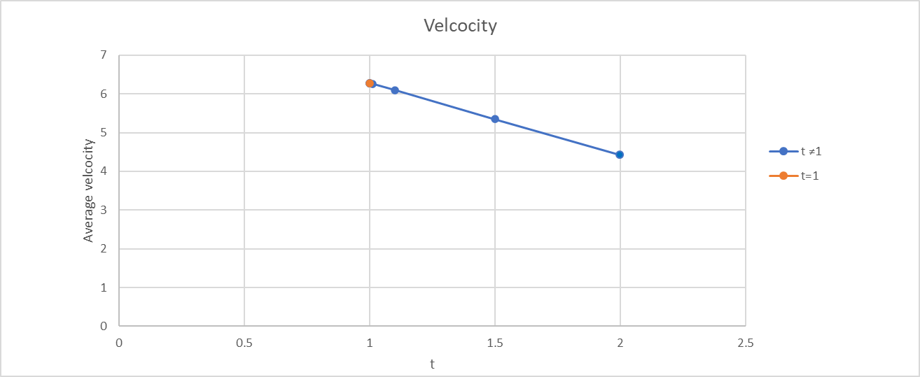

1. The displacement (in centimeters) of a particle moving back and forth along a straight line is given by the equation of motion , where *t* is measured in seconds.

(a) Find the average velocity during each time period:

(i) [1, 2] (ii) [1, 1.1]

(iii) [1, 1.01] (iv) [1, 1.001]

ANS:

1. S(1) = 2sin( = 2sin(= 2\*0 + 3\*( -1) = -3

S(2) = 2sin( = 2sin(= 2\*0+ 3\* 1 = 3

V = [3- (-3) ] / (2-1) = 6

1. S(1) = 2sin( = 2sin(= 2\*0 + 3\*( -1) = -3

S(1.1) = 2sin( = 2sin(

= 2\*(-0.309) + 3\* (-0.951) =( -0.618) +(-2.853)= - 3.471

V = [(-3.471) - (-3) ] / (1.1 -1) = -0.471 / 0.1 = -4.71

1. S(1) = 2sin( = 2sin(= 2\*0 + 3\*( -1) = -3

S(1.01) = 2sin( = 2sin(

= 2\* (-0.0314) + 3\* (-0.9995) = -0.0628 + (-2.9985) = -3.0613

V = [ -3.0613 – (-3) ] / (1.01 – 1) = -0.0613 / 0.01 = -6.13

1. S(1) = 2sin( = 2sin(= 2\*0 + 3\*( -1) = -3

S(1.001) = 2sin( = 2sin(

= 2\* (-0.00314) + 3 \* ( -0.999995) = ( -0.00628) + (-2.999985) =- 3.006265

V = [ -3.006265 – (-3)] / (1.001-1) = - 6.265

(b) Estimate the instantaneous velocity of the particle in Excel when

ANS:

F(x) = {



1. (a) Estimate the value of

by graphing the function in Excel. State your answer correct to two decimal places.

ANS:

= 0.32

(b) Check your answer in part (a) by evaluating for values of *x* that approaches 0 in Excel.

 F(x) = {

1. (a) Estimate the value of the limit to five decimal places. Does this number look familiar?

ANS:

(a) = 100,001 when x>0  = -99,999 when x<0

Therefore ≠

This function is similar to the function of y=, a reciprocal function.



(b) Illustrate part (a) by graphing the function in Excel

1. (a) Graph the function for in Excel. Do you think the graph is an accurate representation of *f*?

ANS: The graph is not an accurate representation of *f.*

When x = 4 ln |x-4| is undefined. ln |x-4| = ∞

Therefore is unidentified.

(b) How would you get a graph that represents *f* better?

ANS:

x x = ∞

f(x) = {

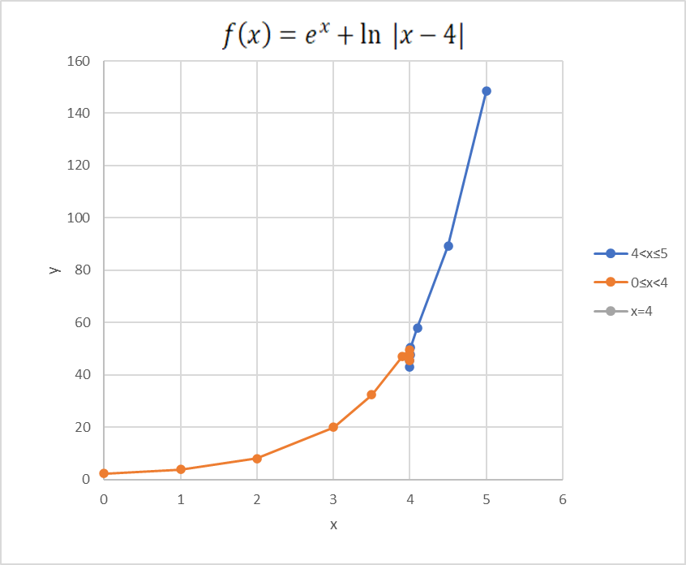

1. (a) Use numerical to find the value of the limit and verify it in Excel

ANS:

since ≠ 0 ≠1 x ≠1 f(x) = = 6



(b) How close to *1* does *x* have to be to ensure that the function in part (a) is within a distance *0.5* of its limit?

ANS: since

Based on the function value if x approaching to 1,

if ɛ < 0.5 then 6- ɛ < f(x) < 6+ ɛ 6-0.5 < f(x) < 6+0.5 5.5 < f(x) < 6.5

5.5 < < 6.5

|x – 1| < δ if 1- δ < x < 1+ δ (x ≠1) 0.9314< x< 1.06491 δ  ≈ 0.06491

